

Global Travelers Morocco Adventure
Trip Snapshot: 14 days in Morocco - April 20 – May 3, 2028, from Marrakech to Casablanca.
Cost: approx. $4,000 (based on 20 travelers - max 30) + airfare (single supplement $1,616)
Meet with local Rotarians and possible service project; private coach with free internet on board; professional English-speaking guide; upscale and luxury accommodations; entrance fees to all monuments included; one water bottle and snacks provided each day; all breakfasts included + 7 dinners, 1 lunch and a food tour; airport transfers included

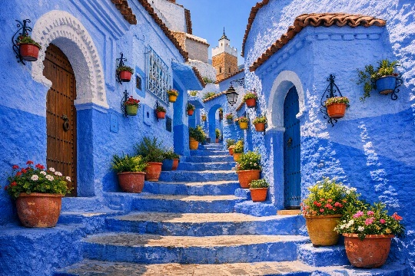
Top Experiences
- Marrakech: Wander colorful souks, visit palaces, gardens and mosques, and go on a food tour.
- Fes: Step into one of the world’s great historic medinas and watch traditional artisans at work.
- UNESCO sites: Guided tours of Meknes (The Imperial City) and Volubilis (ancient Roman ruins).
- Chefchaouen: Photograph peaceful, blue-washed streets tucked into the Rif Mountains.
- Sahara Desert: Ride camels at sunset, sleep under the stars, visit local ethnic tribes, go on a 4 x 4 adventure and horseback ride.
- Atlas Mountains: Travel scenic passes and enjoy sweeping mountain views.
- Rabat: Hassan Tower and Andalusian Gardens
- Casablanca: See the Hassan II Mosque
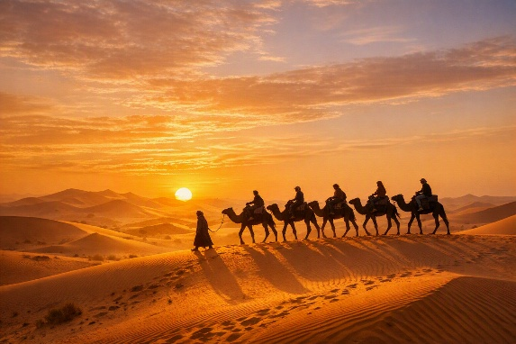
For more information, contact Paula at paularotarygh@gmail.com or Elana at levenscraig@hotmail.com
Travel arranged by kimkim

